NAME: KAVITAPU SWARNA VARSHINI
REG.NO: 192324081
DATE: 14-07-2026

Write a python program for water jug problem
AIM: To write a Python program to solve the Water Jug Problem using the Breadth-First Search (BFS) algorithm.
ALGORITHM:
- Define the capacities of the two jugs, the initial state, and the target amount of water.
- Generate all possible valid operations (fill, empty, and pour between jugs).
- Keep track of visited states to avoid repeating them.
- Continue exploring new states until the target amount of water is obtained.
- Display the sequence of steps from the initial state to the goal state.
CODE:
from collections import deque
cap1, cap2 = 4, 3
target = 2
q = deque ([((0,0), [])])
visited = set ()
while q:
(a, b), path = q.popleft()
if (a, b) in visited:
continue
visited.add((a, b))
path = path + [(a, b)]
if a == target or b == target:
print ("Solution Found!\n")
for x, y in path:
print (f"Jug1 = {x}L, Jug2 = {y}L")
break
next_states = [
(cap1, b), # Fill Jug1
(a, cap2), # Fill Jug2
(0, b), # Empty Jug1
(a, 0), # Empty Jug2
(a-min(a, cap2-b), b+min(a, cap2-b)), # Pour Jug1 -> Jug2
(a+min(b, cap1-a), b-min(b, cap1-a)) # Pour Jug2 -> Jug1
]
for s in next_states:
if s not in visited:
q.append((s, path))

OUTPUT:
Jug1 = 0L, Jug2 = 0L
Jug1 = 0L, Jug2 = 3L
Jug1 = 3L, Jug2 = 0L
Jug1 = 3L, Jug2 = 3L
Jug1 = 4L, Jug2 = 2L

IMAGE:
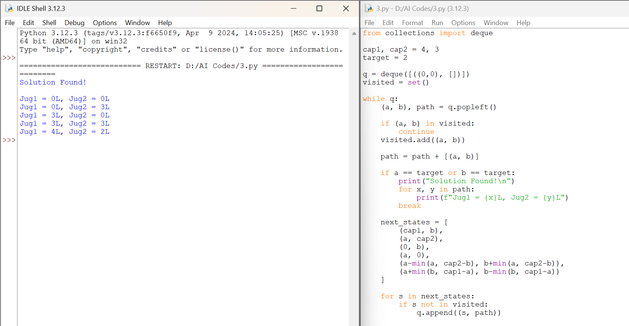

RESULT:
The Python program was executed successfully and solved the Water Jug Problem using the Breadth-First Search (BFS) algorithm. The required 2 liters of water was obtained, and the sequence of states from the initial state to the goal state was displayed.

